REQUIREMENT ANALYSIS

In this chapter, we will discuss and analyses about the developing process of Library Management System including Software Requirement Specification (SRS) .The functional and non-functional requirements is included in SRS part to provide complete description and overview of system requirement before the developing process is carried out. *S*

*FUNCTIONAL REQUIREMENTS*

Functional requirement simply points to the statements of services that the system should offer, how the system should respond to specific inputs and how the system should perform in specific situation, (Mittal, 2012). These requirements essentially illustrate the functionality of the system or system services. Some system functions define the system significance thus without the existence of such functions, it will be tantamount to having a useless object.

Product backlog

Definition of done

Done means coded up to standards, reviewed, implemented and tested unit with 100% test automation, integrated and documented.

The functional requirements for the proposed system are as follows:

* The system must have access restriction ability through the use of unique identifiers (usernames) and passwords.
* System users must have different access levels of which each access level should have a custom interface with functions and privileges specific for that user’s access level.
* There should be restriction to the subsequent chapters before completion of the preceding chapter.

*Delivery requirements*

The requirements are to be delivered in 2-4weeks time.

Requirements

1. Librarian

* The system will create new users
* The system will delete users
* The system will edit user accounts information
* The system will issue books
* The system will modify users

1. Lecturer

* The system will display the lecturer members’ details:

1. Employee Number
2. Name
3. Address
4. Age
5. Gender
6. phone
7. Student

* The system will display the student details:

1. Name
2. Student registration
3. Age
4. Gender
5. phone
6. Address
7. phone
8. Books

* The system will display the books details:

1. Record number
2. Author Name
3. Book name
4. Book code
5. Books available
6. Number of copies

Library Management System is a computerized system which can helps user (librarian) to manage the library daily activity in electronic format. It can help user to manage the transaction or record more effectively and time-saving.

*SYSTEM REQUIREMENTS*

Non-functional Requirements

**Products Requirements**

*Efficiency requirements*

With the library management system, librarian should be able to process faster when they process book transaction. In addition, with the use of number strap, librarian can type the book id one by one, and it enable librarian to type the book id instantly.

*Reliability requirements*

The system must perform accurately towards students / lecturers’ request. For example, when the librarian saves the edited profile detail, after they review their detail, the details must be change according to the latest details that they have updated. When lecturer return the book after the expired date, the fine should be calculate accurately.

*Usability requirements*

This system must be designed with user-friendly and easy to use by the librarian so that the user can perform their job nicely. It must have a clear instruction to guide user through the system. Besides that, the description of error message it should be clear.

**Organizational Requirements**

In implementing the system, it uses the C++ as the main programming language and tools.

Dev. ++, Code Blocks 17.2 and Net Beans 8.0 needs to be installed.

**External Requirements**

*Legislative requirements*

The information that use must be acknowledge by the authorized people so that it has no violating the law. This information is copyrighted and protected by the law. Besides that, when visitors are not allowed to enter the library.

*Security requirements*

This system must be highly secure in the login part. It is because the report can only view by authorized level. Chief librarian can perform most of the process except viewing report module and log file module.

FUNCTIONAL REQUIREMENTS

**Description of Feature**

This feature used by the user (librarian) to login into the new proposed system. They are required password before they are allows entering the new proposed system. The librarian password will be verified allowed to enter the new proposed system and can be performing by librarian to register new book to the library. This feature is found at book maintenance part. User can search the book based on book title, category or publisher. Once user key in a character into the Search console, system will filter and show out the books which fulfil the search criteria. It also allows the librarian to register the lost book when student / lecturer lost the book.

***Functional Requirements***

* The new proposed system must only allow the librarian password to enter the system and be able to perform authorization process which decides what the user’s level can access to send the correct password and must be able to verify the information.
* The new proposed system must enter the correct copies quantity into book copies. The new proposed system must be able to search based on selected search type (book title etc.), filter the book based on the keyword entered and show out the filtered book.
* The new proposed system must able to auto generate the publisher id and must not generate the same publisher id. If enter on search the publisher system should show out the new proposed system should not allow publisher id to be change without first request it to change. The new proposed system should be able to validate the id, email and other information.
* The new proposed system must able to search which book was rent by students and lecturer.
* The new proposed system must able to show out the correct information about the transaction happens on particular date, and also show the information correctly whether it is rental report or return report.
* The same book should not appear repeatedly and only appear only when the book’s category is selected.

SYSTEM ANALYSIS

In this chapter, the current system’s contribution, procedures and productions are deeply discussed to show how the system components interact. For accurate analysis of the new proposed system to be done, some fact gathering techniques like questionnaires, interviews, record inspection and observations are used to collect data. The best alternative is therefore the new proposed system. In simple terms, the aim of the analysis phase is to specify requirements thus the functional and non-functional requirements of the proposed system are specified herein. [1]

2.1. INFORMATION GATHERING TECHNIQUES

A methodology is defined by two things which are the detailed research methods through which collection of data is done and the viewpoints upon which the collection and evaluation of data are based. In order to have knowledge regarding, information gathering techniques were used and these were questionnaires, observations and interviews. In order to define the requirements of a system, facts must be gathered from the participants. Ideally, the information acquired will allow a well-defined, accurate, and complete explanation of how the institute functions as well as the students and lecturers, functions and data involved. [2]

2.1.1. TRADITIONAL METHODS

Information below was gathered from different users, which needed to delivery for students and lecturers.

Interviews:

Basically, the focus of the interview was on seeking views and clarification from the internal and external interested parties (Participants, one of the limiting factor during interviews is bias which in this case the interviewer avoided such bias and or prejudice by asking context free questions that refrain from the respondent’s agreement or disagreement.)[3]

Questioning:

By questioning all those who are involved in this business venture including students / lecturers / other staff will help on how to improve the system through their complaints. Hearing what their say and help to build a system which is convenient and user friendly. [4]

Questionnaires:

According to Laws et al (2013), a questionnaire is a list of questions either given or sent to respondents who fill the questionnaire themselves. Questionnaires are another way of data gathering which was used to collect information at UZ School of Technology. A mass production of questionnaire was done and these questionnaires were distributed. [5]

Observation

Records Inspection

Study of existing organizational documents, forms and reports. This is the study of organizational charts and statistics that show useful information about a certain procedure. In order to gain an insight on the pass rate level of students in the previous years, record inspection was done.

DATA FLOW DIAGRAM

DFD MODELLING

Refer as articulated that data analysis is a way to support decision making through evaluation of various data elements, modelling and transforming data so as to find useful information to reach a decision. Illustration of the data modelling is done by making use of data flow diagrams (DFD) that provide an easy way of visualizing object relationships. Data analysis enables one to use logical reasoning and analysis so as to develop a solution [6].

ACTIVITY DIAGRAM

Activity diagram for Library Management System. The activity diagram used to describe flow of activity through a series of actions and it is an important diagram to describe the system. It described as an action or operation of the system. Below are the activity diagram for librarian and students operations:

3. DESIGN

2.5 DATA FLOW DIAGRAM

DFD MODELLING

Refer as articulated that data analysis is a way to support decision making through evaluation of various data elements, modelling and transforming data so as to find useful information to reach a decision. Illustration of the data modelling is done by making use of data flow diagrams (DFD) that provide an easy way of visualizing object relationships. Data analysis enables one to use logical reasoning and analysis so as to develop a solution [6].

ACTIVITY DIAGRAM

Activity diagram for Library Management System. The activity diagram used to describe flow of activity through a series of actions and it is an important diagram to describe the system. It described as an action or operation of the system. Below are the activity diagram for librarian and students operations:

The following activity diagrams are for

1. lecturer
2. book
3. librarian
4. student

# Z:\old work\R1712039-Class diagrams\lecturer.jpgZ:\PROJECT\boooks.jpgC:\Users\R1712039.UZSOT.010\Documents\VPProjects\Activity Diagram1.jpg

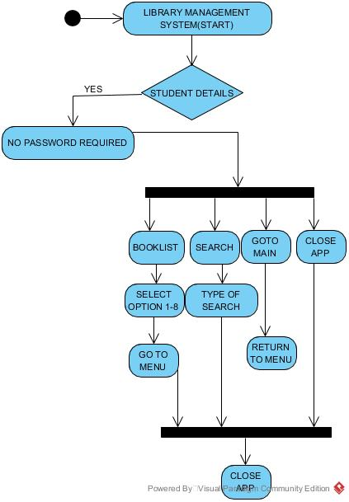

The use case diagram are usually referred to as behaviour diagram used to describe the actions of all participants partake in a system. All participants describe in use case are actors and the functionality as action of system.

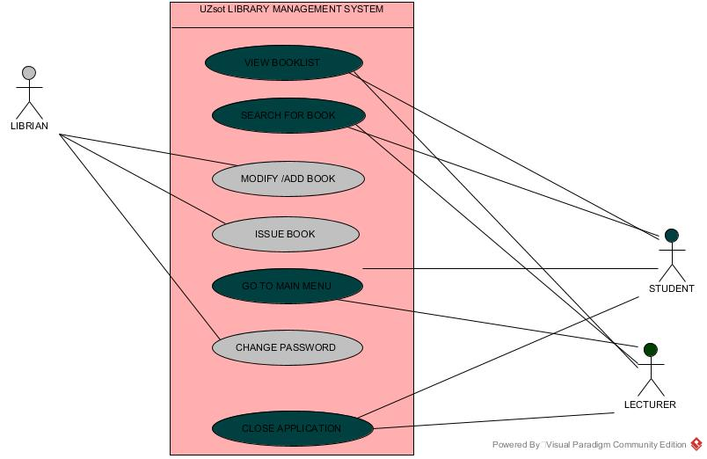

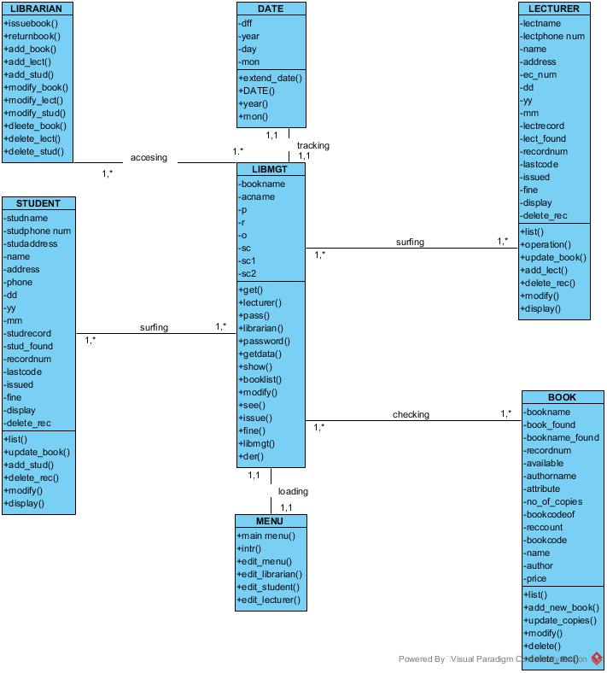

The analysis class design show the segmentation of the system and the outlook of the system interaction.

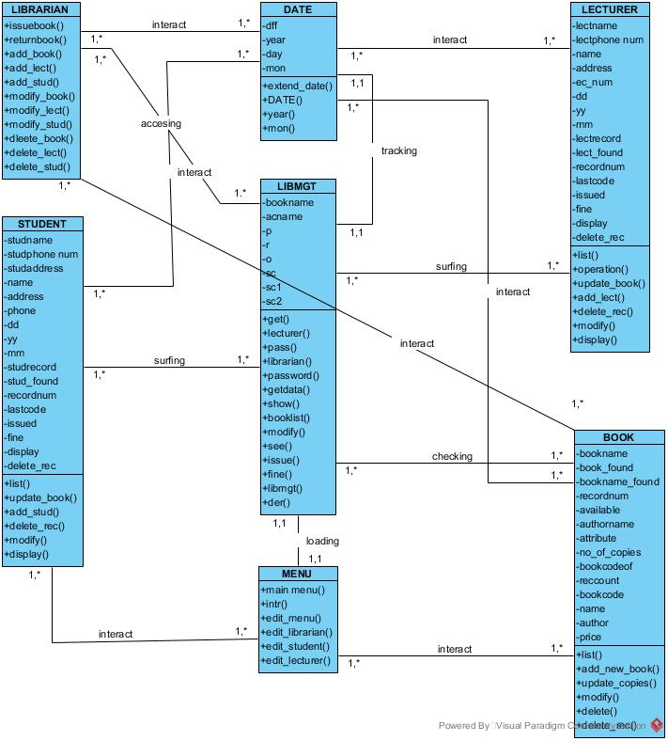

Sequence diagram descries interaction among classes in terms of an exchange of message over time. Sequence diagram demonstrate the behaviour of objects in a use case by describing the object and messages they pass.

